GENAI WORKSHOP – ACTIVITY PACK

SCAN FOR WORKSHOP RESOURCES SCAN FOR MENTEE CHAT



Code - 2364 8330
URI - https://lnk.ink/genai Participation Link - https://www.menti.com/al9526s2cgjz

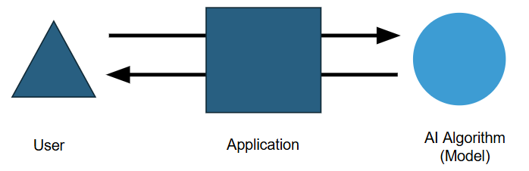
GENAI APPLICATION OVERVIEW

……………………………
……………………………
……………………………
……………………………
……………………………
……………………………

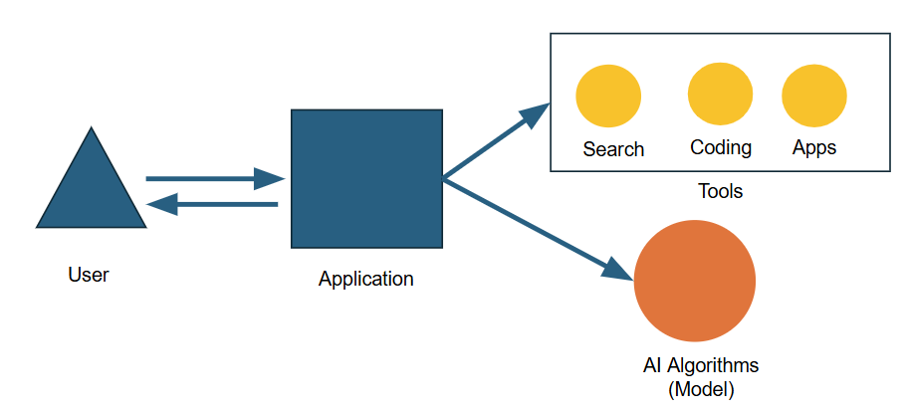

……………………………
……………………………

……………………………
……………………………
……………………………
……………………………
……………………………
……………………………

PROMPT ENGINEERING CHEATSHEET
THE PERFECT PROMPT FORMULA
A prompt is how we talk to AI to get the output we want.
WHAT IS A PROMPT?
[02] PERSONA
The explicit role or professional identity the AI should adopt to frame its expertise.
[01] TASK
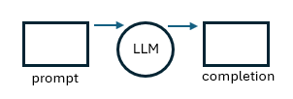
The specific action or objective you want the AI to achieve (e.g., "Write", summarize").
Combined Elements = Maximized Control over Generative Output
Good Prompt = [Task] + [Persona] +
[Context] + [Format] +
[Exemplar] + [Tone]
THE LLM INFERENCE LIFECYCLE
Prompt:
The input text passed to the Large Language Model (LLM).
Completion:
The corresponding output generated by the model.
Inference:
The act/process of using the model to generate text.
Context Window:
The maximum amount of total input tokens (plus output tokens) that a language model can process at once.
CORE TERMINOLOGY
It is any instruction or input you give an AI model to tell it what you want.
This can take many forms:
- A question or a direct task
- A complex problem or statement
- A detailed set of instructions
- A role description (persona)
- Even a specific example

[03] CONTEXT
The emotional or professional flavor of the text (e.g., casual authoritative, encouraging).
[05] EXEMPLAR
[06] TONE
Few-shot training examples embedded within the prompt to guide style and quality.
Background details, user data, or surrounding circumstances that anchor the request.
The visual layout or structural style required for output (e.g., Markdown table, bullet points).
[04] FORMAT

Notes: ………………………………………………………………………………………………………………………………………………………………………………………………………………………………………………………………………………………

PROMPT TEMPLATE
I am working on [context: briefly describe the situation, issue, department, audience, or purpose].
Act as a [persona: policy advisor / communication specialist / senior analyst / administrative officer].
I need you to [task: summarize / rewrite / compare / draft / analyze / prepare / simplify / improve].
Use the following information:
[input: paste text, notes, document excerpt, issue description, or data]
Please provide the output as [format: bullet points / table / brief / email draft / checklist / action plan].
Use a [tone: formal / simple / diplomatic / concise / professional / executive-level] tone.
Follow this style or example, if useful:
[exemplar: paste sample wording, previous format, preferred structure, or example output]
Before giving the final answer, mention any assumptions, missing information, risks, or points that should be verified.

**********
AI SAFETY CHECKLIST

Is AI suitable for this task?
Have I removed confidential or personal information?
Have I avoided sharing private investor or internal data?
Have I verified important facts, dates, laws, policies, and procedures?
Is the content clear, professional, and appropriate?
Are assumptions clearly separated from facts?
Could the content be biased, unfair, or misleading?
Has a responsible person reviewed it before official use?
Are required approvals completed?
Is the final version safe to share?

SIMPLE RULE
Use AI for drafting, summarizing, brainstorming, and organizing work.
Do not use AI as the final authority for official decisions, legal matters, policies, or confidential information.
AI BUSINESS VALUE MAPPING

The Board of Investment is planning an Investor Summit.
- MARK THE ACTIVITIES
No. | Activity | Can AI Help? | Est. Time Without AI | Est. Time With AI
1 | Research similar investor summits and best practices | ☐ | ____ | ____
2 | Identify target audience and stakeholders | ☐ | ____ | ____
3 | Prepare an event concept note | ☐ | ____ | ____
4 | Draft the full event proposal | ☐ | ____ | ____
5 | Create the event agenda | ☐ | ____ | ____
6 | Prepare a budget outline | ☐ | ____ | ____
7 | Create a presentation for senior management approval | ☐ | ____ | ____
8 | Draft invitation emails to investors and officials | ☐ | ____ | ____
9 | Create meeting notes and calendar descriptions | ☐ | ____ | ____
10 | Prepare social media posts or marketing captions | ☐ | ____ | ____
11 | Create infographic content for promotion | ☐ | ____ | ____
12 | Write a script for a promotional video | ☐ | ____ | ____
13 | Create website content for the event page | ☐ | ____ | ____
14 | Summarize feedback after the event | ☐ | ____ | ____
15 | Draft a post-event report | ☐ | ____ | ____

Notes:
………………………………………………………………………………………………………………………………………………………………………………………………………………………………………………………………………………………………………………………………

(B) IDENTIFY BUSINESS VALUE
Saves staff time |  | Supports faster decision-making
Reduces repetitive manual work |  | Helps create professional marketing materials
Improves document quality |  | Reduces delays in approvals and coordination
Speeds up event planning |  | Helps officers focus on higher-value work
Helps create better presentations |  | Improves consistency in official communication
Improves communication with investors |  | Supports better follow-up after the event

